

**Gardening at Linwood Community Resource Centre**

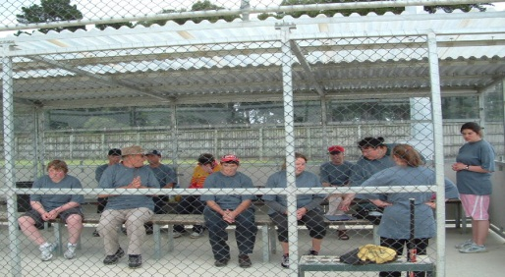

**Helen Anderson Trust T-Ball tournament held at Foundation ballpark**

**CRITERIA**

Clients must have an intellectual disability.

The Trust takes into account other existing needs an individual may have.

The Trust enjoys working within a wider team (Client, Family/whanau/ Doctors/Specialists etc), recognising a holistic approach.

For referrals or if you require further information, contact:

|  |
| --- |
| **The CEO**  **Helen Anderson Trust**  **P.O. Box 27 122**  **Christchurch** |

The Trust is based in Shirley in Christchurch

**Contact:**

**CEO: Debbie Andrews**

(03) 385 9094

Cell phone: 027 248 4565

*The Helen Anderson Trust is a registered Charitable Trust and registered organization with relevant Government Departments. The Trust meet regular monitoring and criteria associated with such registrations*



**To assist individuals in developing their abilities, enabling them to reach their fullest potential**

The Helen Anderson Trust was established in 1993, after identifying needs within the Christchurch area for the support of intellectually disabled persons.

* The policy of the Trust is to provide programmes designed for individuals with components of personal choice and support.
* Programmes are designed with realistic goals and targets.
* It is not expected that all clients will be independent but will further maintain their independence in a particular skill.
* Individual personal plans and programmes (IPP) to meet individual needs.
* Programmes will be developed and supported, targeting individual’s needs, abilities and aspirations.
* Developing skills toward community inclusion.
* Regular reviews of personal programmes, according to individual needs.



**EXAMPLES OF PERSONAL GOALS AND DREAMS BEING REACHED**

Duke of Edinburgh / HAT award programme sections

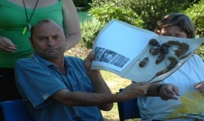

Service, Physical, Skills, Expedition

Volunteer work, Work experience

Meals on Wheels, Gardening, Swimming

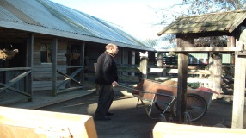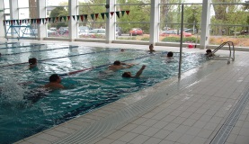

Community orientation, Social interaction

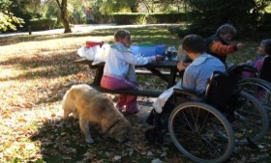

Communication, Music appreciation

RDA – Riding for the Disabled, Cricket, T-Ball and many more.

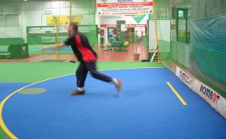

**TARGETED CLIENT GROUP**

All persons with an intellectual disability are considered as potential clients.

Programmes are designed in consultation with client, family/whanau, and advocate to meet the unique needs of the individual.

The Trust will endeavour to meet needs that will benefit the client and increase their self-esteem, enjoyment and independence, toward inclusion in their community.

**REFERRALS**

The Helen Anderson Trust has an open referral policy.

Referrals will be accepted from any source:

* Families/ whanau and caregivers
* Community service groups and individuals
* General Practitioners
* Educational services

.